## A

**Project Report on**

**PETXHUB**

**In Partial Fulfillment of**

## Bachelor of Computer Application (B.C.A) Gujarat University (2023-2024)



**Developed By**

## ANSH ANANDANI (202112102062)

**PRATHAM LALWANI (202112102134)**

**RAHUL RAGHANI (202112102196)**

## (SEM – V Bachelor of Computer Application)

**A Project Report On**

## PETXHUB

**(Animal Health Care Services Providing Web app)**

Submitted to Faculty of

Bachelor of Computer Application

In partial fulfillment of the requirement of the award for the degree Of

Bachelor Of Computer Applications



**Gujarat University Under the guidance of**

Name of Faculty:

**Prof. Vanita Mistry** Submitted by:

|  |  |
| --- | --- |
| Students Names | Enrolment Numbers |
| ANANDANI ANSH RAMESH | 202112102062 |
| LALWANI PRATHAM VICKY | 202112102134 |
| RAGHANI RAHUL HARESHBHAI | 202112102196 |

## ASIA PACIFIC BCA COLLEGE

**[November-2023]**



This is to certify that this project entitled “**PETXHUB**” is carried out by **Ansh Anandani (202112102062), Pratham Lalwani (202112102134) & Rahul Raghani (202112102196)** studying at Bachelor of Computer Application in 5th semester (Asia pacific BCA College, Ahmedabad) for partial fulfillment Bachelor of computer application degree to be awarded by Gujarat University. This project work has been carried out under faculty guidance. The project is fit to be considered for evolution for the degree of Bachelor of computer application.

Date:

Place: Ahmedabad

|  |  |
| --- | --- |
| Guide Name  Prof. Vanita Mistry | Vice – Principal Incharge |

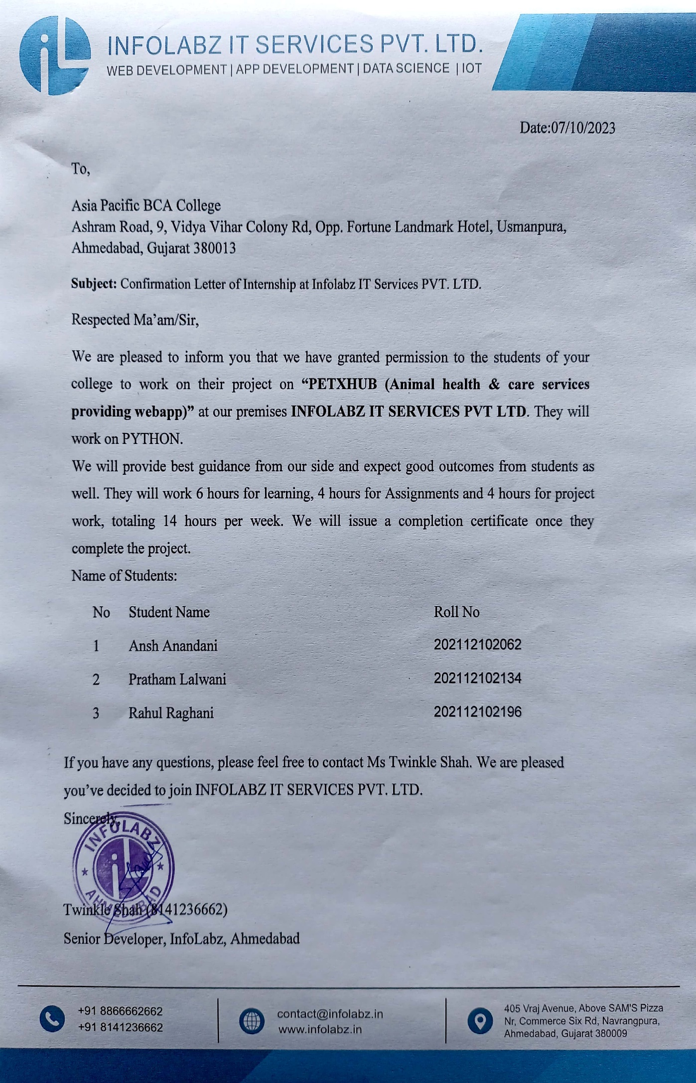

## Acknowledgement

We would like to express our special thanks of gratitude to our project guide **Prof. Vanita Mistry** as well as our vice-principal incharge, Who gave us the golden opportunity to do this wonderful project on the topic **“PETXHUB”**, Which also helped us in doing a lot of research and We came to know about so many new things We are really thankful to them.

Secondly, We should also like to thank our parents and friends who helped us a lot in finalizing this project within the limited time frame.

|  |  |
| --- | --- |
| **Date:** | **Students Name:**  Ansh Anandani (202112102062) Pratham Lalwani (202112102134)  Rahul Raghani (202112102196) |
| Place: Ahmedabad | BCA (5th ) |

## INDEX

|  |  |  |
| --- | --- | --- |
| **Chapter No.** | **Title** | **Page No.** |
|  | Index Page | 01 |
|  | List of Figures | 02 |
|  | List of Tables | 03 |
| 1 | Company Profile | 04 |
| 2 | Project Profile   * 1. Project Summary   2. Project Profile   3. Objectives   4. Existing System   5. Proposed System   6. Tools & Technologies | 07 |
| 3 | System Flow Diagram | 20 |
| 4 | Data Flow Diagram   * 1. Context Level Diagram   2. DFD Level-1   3. DFD Leve1-2 | 23 |
| 5 | Entity Relationship Diagram | 39 |
| 6 | Data Dictionary | 43 |
| 7 | Conclusion | 61 |
| 8 | Bibliography | 63 |

**LIST OF FIGURES**

|  |  |  |
| --- | --- | --- |
| **Figure No.** | **Title** | **Page No.** |
| Figure 4.0 | System Flow Diagram Symbols | 21 |
| Figure 4.1 | System Flow Diagram | 22 |
| Figure 4.2 | DFD Symbols | 24 |
| Figure 4.3 | Data flow Diagram Level-0 (Context Level) | 26 |
| Figure 4.4 | Data flow Diagram LEVEL1-Admin | 28 |
| Figure 4.5 | Data flow Diagram LEVEL1-User | 30 |
| Figure 4.6 | Data Flow Diagram Of Admin [Login] | 32 |
| Figure 4.7 | Data Flow Diagram Of Admin [Services] | 33 |
| Figure 4.8 | Data Flow Diagram Of Admin [Vets] | 34 |
| Figure 4.9 | Data Flow Diagram Of User [Login] | 36 |
| Figure 4.10 | Data Flow Diagram Of User [Services] | 37 |
| Figure 4.11 | Data Flow Diagram Of User [Adoption] | 38 |
| Figure 5.1 | ER Diagram Symbols | 41 |
| Figure 5.2 | ER Diagram | 42 |

**LIST OF TABLES**

|  |  |  |
| --- | --- | --- |
| **Table No.** | **Title** | **Page No.** |
| Table 6.1.1 | Role Table | 45 |
| Table 6.1.2 | Login Table | 46 |
| Table 6.1.3 | Adress Table | 47 |
| Table 6.1.4 | Service Category Table | 48 |
| Table 6.1.5 | Service Table | 49 |
| Table 6.1.6 | Card Table | 50 |
| Table 6.1.7 | Service Booking Table | 51 |
| Table 6.1.8 | Vet Table | 52 |
| Table 6.1.9 | Pet Shop Table | 53 |
| Table 6.1.10 | Blog Table | 54 |
| Table 6.1.11 | Animal Shelter Table | 55 |
| Table 6.1.12 | Animal Table | 56 |
| Table 6.1.13 | Adoption Table | 57 |
| Table 6.1.14 | Rescue Center Table | 58 |
| Table 6.1.15 | Contact Table | 59 |
| Table 6.1.16 | Feedback Table | 60 |

# 

# CHAPTER : 1

**COMPANY PROFILE**

**COMPANY PROFILE**



|  |  |
| --- | --- |
| **Company Name** | INFOLABZ IT SERVICES PVT. LTD. |
| **Director Name** | Mr. Chintan Nagrecha |
| **Contact No.** | 8866662662 |
| **Email Id** | [info@infolabz.in](mailto:info@infolabz.in) |
| **Address** | Vraj Avenue, 405, above SAM'S Pizza, nr.  Commerce Six Road, Navrangpura,  Ahmedabad, Gujarat 380009 |
| **Website** | [www.infolabz.in](http://www.infolabz.in) |

Established in 2011, we are a distinguished entity within the IT industry, operating as a subsidiary of a prominent parent IT corporation. Our enduring presence in the market attests to our solid reputation and unwavering commitment to excellence.

Our core strength lies in our highly qualified and experienced team, meticulously prepared to confront and conquer any challenges that may arise.

Our dedicated team comprises seasoned experts proficient in a wide array of cutting-edge technologies. Additionally, we maintain specialized teams for UI/UX and graphic design. Our clientele spans the globe, with hundreds of satisfied clients benefiting from our comprehensive services.

In this segment, we maintain dedicated teams specifically tasked with API and web service management, as well as crafting contemporary material designs. Our unyielding dedication to innovation is evident in every app we create, as we continually seek to expand our horizons and knowledge with each project.

InfoLabz proudly offers industry-oriented live project training, catering to students pursuing CE/IT (BE/B.TECH & DIPLOMA ENGINEERING), BCA/MCA, BSc IT/MSc IT degrees. Our training programs provide students with invaluable hands-on experience, bridging the divide between theoretical knowledge and real-world application. This immersive experience empowers students to gain a deeper understanding of engineering principles and apply their acquired skills to develop practical software and live websites.

# CHAPTER : 2

# PROJECT

# SUMMARY & PROFILE

* **2.1 PROJECT SUMMARY:-**
* Our website is a place where you can find everything you need to take care of animals. Here you can conveniently connect with veterinarians. You can book appointments with vets, find nearby pet shops and shelters, and get help from helpline numbers and rescue centers.
* We also have options for adopting animals and making donations to support their well-being. Our goal is to make animal care easy and accessible for everyone while promoting kindness and compassion towards animals.
* **2.2 PROJECT PROFILE :-**

|  |  |
| --- | --- |
| Project Title | PETXHUB (Animal Health Care Services Providing Web App) |
| Project category | Web application |
| Objectives | Using this web application a user can Book Various range of services for their animals at one-stop platform and easily connect to expert vets. |
| Front end | Html  CSS3  JS (javascript)  Bootstrap 4 or 5 |
| Back end | Python  Django (framework) |
| Tools | Visual studio code  Pycharm  Browsers(Chrome/Explorer/Firefox)  Python Interpreter |
| Documentation tools | Google docs & WPS Office |
| Guide | Prof. Vanita Mistry |
| Group no | 32 |
| Developed by | Ansh Anandani (202112102062 )  Pratham Lalwani (202112102134)  Rahul Raghani (202112102196) |

* **2.3 OBJECTIVES:-**
* The main objective of our animal health/care services provider web App is to provide a one-stop platform for Users to access a range of services conveniently.
* Our website aims to provide various services like booking of animals related all types of services , enable users to search for nearby vets, pet shops, animal shelters, helpline numbers, and rescue centers.
* Our platform also allows users to participate in animal adoption and donation programs.
* Additionally, In our platform there is also a portal for animal education.

### 2.4 EXISTING SYSTEM:-

* The current system for managing pet care services is primarily manual and offline.
* Many times people have to face very difficult situations in finding reliable service providers, expert vet , veterinary center, nearby pet shops, and shelters.
* The process of participating in animal adoption is time-consuming and involves multiple phone calls or visits.
* Many times the owners of pets do not even know about the common and basic things of their pets such as Animal Behavior, Nutritional Needs, Body Language, Health and Disease, Grooming and Hygiene, Exercise and Physical Activity etc..

### 2.5 PROPOSED SYSTEM:-

* Creating User-friendly interface for users to book veterinary appointments, search for nearby pet shops and shelters, and access essential information.
* Providing reliable services , experts Animal Doctors , and veterinary centers.
* Integration of helpline numbers and rescue centers for immediate support in times of emergency.
* Providing Animals Education web page which gives information about their habits, their diets, behaviors and their basic needs.
* Centralized database for storing and managing information related to pet care services, ensuring easy access and retrieval.

### 2.6 TOOLS & TECHNOLOGIES:-

### Tools :

- Pycharm

- Python Interpreter

- Visual Studio Code

- Draw.io

- Browser (Chrome/Explorer/Firefox)

### Technologies :

**- Front-end** Html 5, CSS3 , Bootstrap5, JavaScript

**- Back-end :** Python , Django Framework

* **HTML5:-**



* HTML stands for Hyper Text Markup Language. It is used to design web pages using a markup language.
* HTML describes the structure of a web page. It tell the browser how to display the content.
* HTML5 is the fifth and current version of HTML. It has improved the markup available for documents and has introduced application programming interfaces (API) and Document Object Model (DOM).
* **CSS3:-**



* CSS, which stands for Cascading Style Sheets, is a crucial technology used in web development to control the presentation and styling of web pages.
* It plays a vital role in defining how HTML elements should be displayed on a screen, making web pages visually appealing and user-friendly.
* CSS saves a lot of work. It can control the layout of multiple web pages all at once.
* **JAVA SCRIPT:-**



* JavaScript is a client-side scripting language developed by Brendan.
* Each JavaScript can be run on any operating system and almost all web browsers.
* The programs in this language are called scripts.
* They can be written right in a web page’s HTML and run automatically as the page loads.
* Scripts are provided and executed as plain text, They don’t need special preparation or compilation to run.
* In this aspect, JavaScript is very different from another language called Java.
* **Bootstrap5:-**



* Bootstrap 5 is the fifth major version of the Bootstrap front-end framework.
* Bootstrap 5 is a versatile and widely used tool for web development, offering a robust foundation for creating responsive and visually appealing web projects.
* It is a popular and open-source toolkit that developers use to create responsive and visually appealing websites and web applications.
* The main differences between Bootstrap 5 and Bootstrap 3 & 4, is that Bootstrap 5 has switched to JavaScript instead of Jquery.
* **Python:-**



* Python is a widely used general-purpose, high level multi-paradigm programming language.
* It was created by Guido van Rossum in 1991 and further developed by the Python Software Foundation.
* It was designed with an emphasis on code readability, and its syntax allows programmers to express their concepts in fewer lines of code.
* Python is a programming language that lets you work quickly and integrate systems more efficiently.
* There are two major Python versions: Python 2 and Python 3. Both are quite different.
* Why Python?
* Python works on different platforms (Windows, Mac, Linux etc).
* Python has a simple syntax similar to the English language.
* Python has syntax that allows developers to write programs with fewer lines than some other programming languages.
* **Python Django Frame Work :-**



* Django is a high-level, open-source web framework for building web applications in Python.
* Django is written in Python, a widely used and versatile programming language, making it accessible to a broad developer community.
* Django follows the Model-View-Controller (MVC) architectural pattern, although it uses its own variation known as Model-View-Template (MVT)

.

* It's suitable for building a wide range of web applications, from simple websites and blogs to complex, data-driven platforms.
* Django includes built-in authentication and authorization systems, making it easy to handle user management, login/logout, and permissions.

# CHAPTER : 3

# SYSTEM FLOW DIAGRAM

### SYSTEM FLOW DIAGRAM :-

### The system flow diagram is a visual representation of all processes in sequential order.

### The System flow chart diagram is a graphical representation of the relation between all the major parts or steps of the system. Flow chart diagrams can not include minor parts of the system.

+

### SYSTEM FLOW DIAGRAM SYMBOLS :

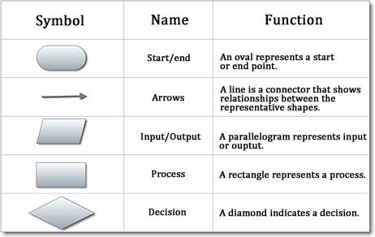

[**Figure 4.0:** System Flow Diagram Symbols]

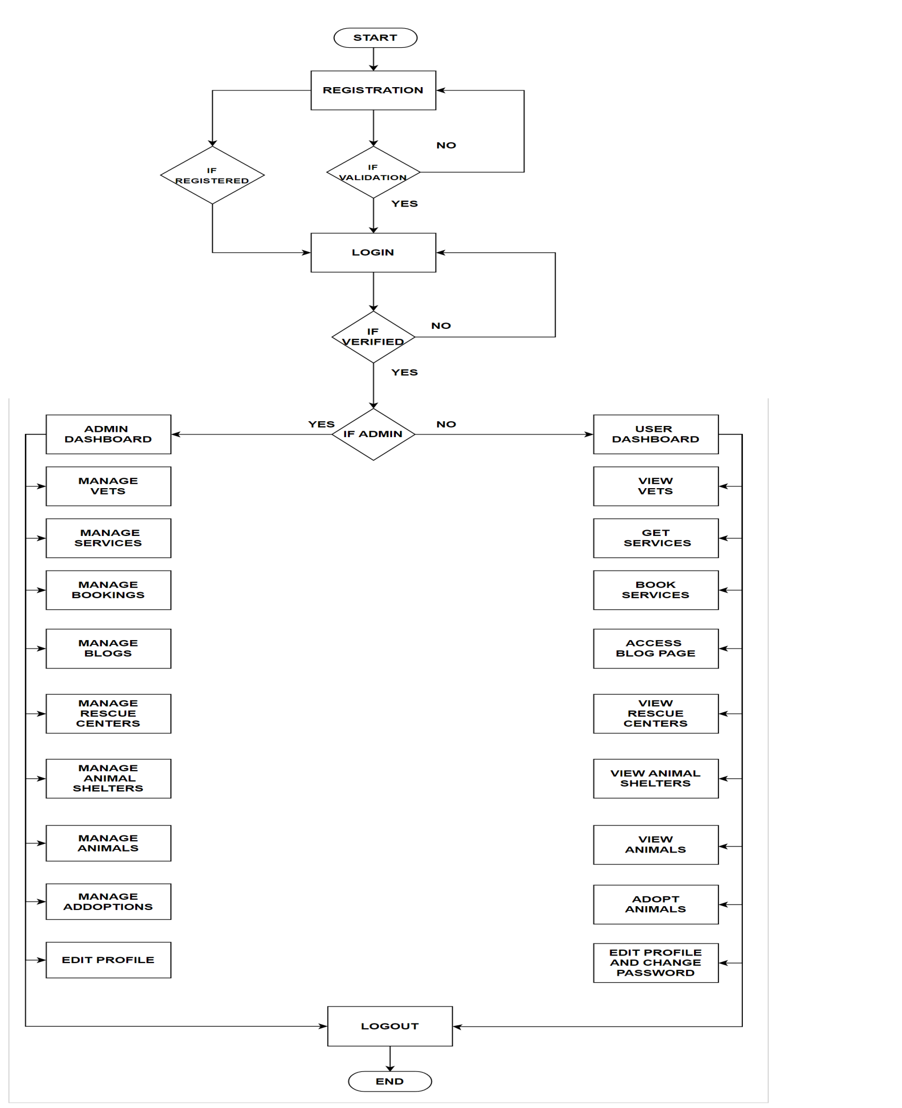

[**Figure 4.1**: System Flow Diagram]

# CHAPTER : 4

# DATA FLOW

# DIAGRAM

* **Data Flow Diagram:**
* A Data Flow Diagram (DFD) is a traditional visual representation of the information flows within a system.
* A neat and clear DFD can depict the right amount of the system requirement graphically. It can be manual, automated, or a combination of both.
* It shows how data enters and leaves the system, what changes the information, and where data is stored.
* Data flow diagrams are categorized by level. Starting with the most basic, level 0, DFD get increasingly complex as the level increases.

### Symbols used in data flow diagrams are:

Process

Entity

Data Store

Flow

**[Figure 4.2 :** DFD Symbols**]**

### 

### 

### CONTEXT LEVEL

### DIAGRAM

### 4.1 Context Level Diagram:

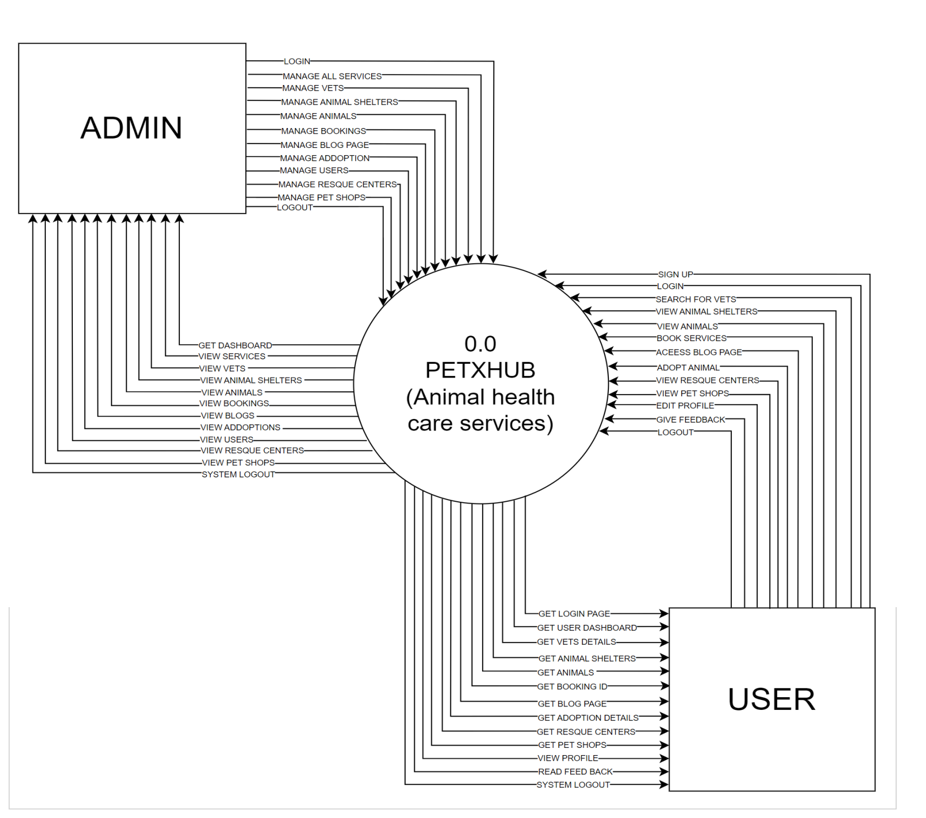

**[Figure 4.3:** Data flow Diagram Level-0]

### 

### 

### 

### 

### 

### 

### DFD LEVEL 1

### ADMIN DIAGRAM

### 4.2.1 Level-1 Data Flow Diagram of Admin:

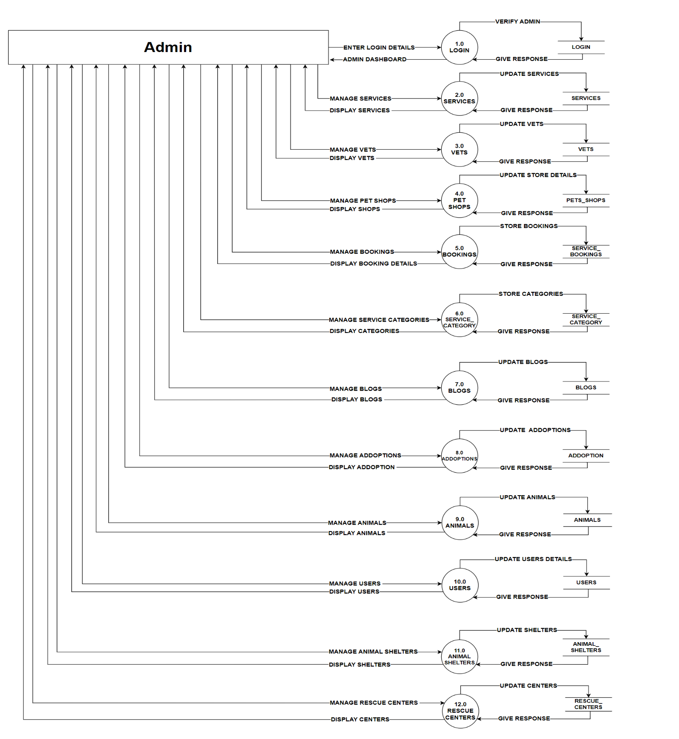

**[Figure 4.4 :** Data flow Diagram LEVEL1-Admin]

### DFD LEVEL 1

### USER DIAGRAM

**4.2.2 Level-1 Data Flow Diagram User:**

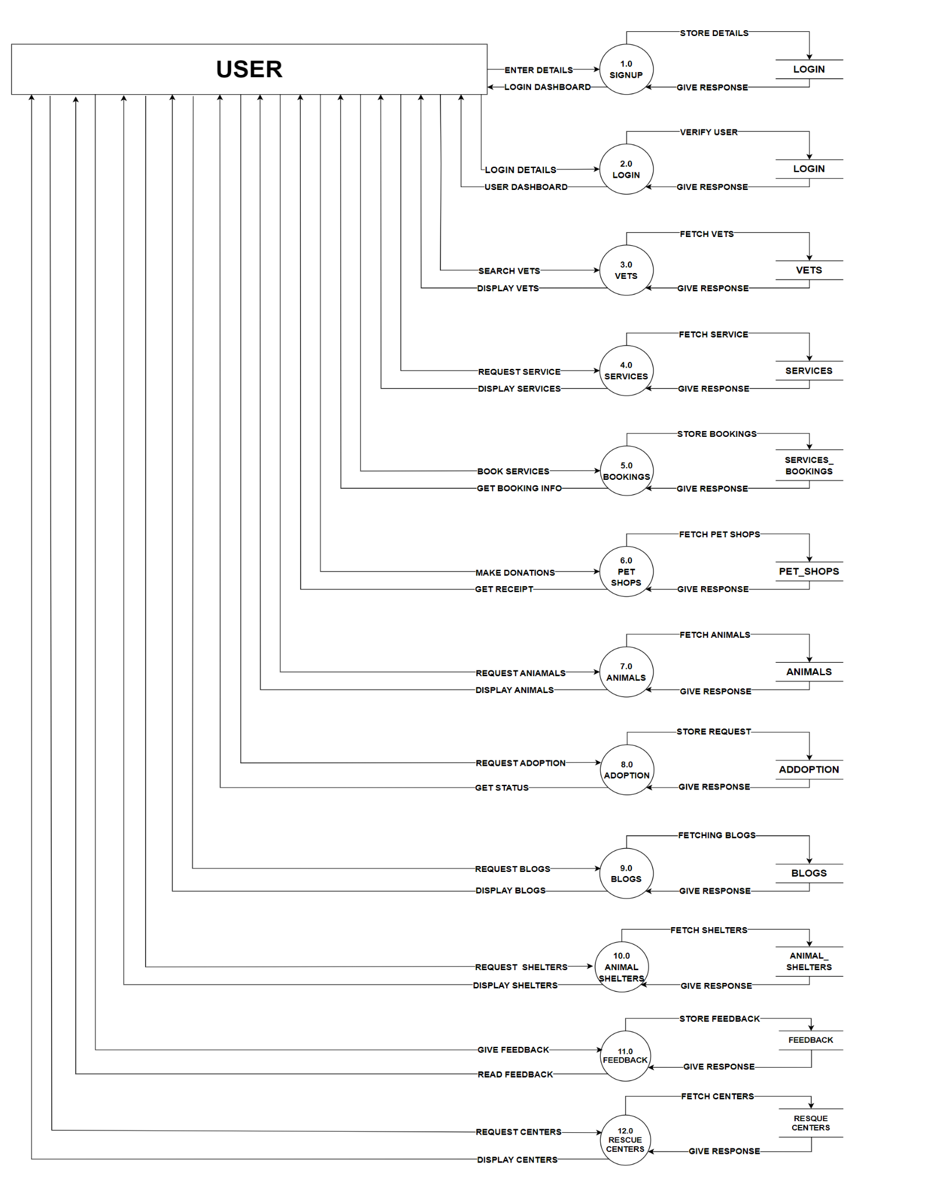

**[Figure 4.5 :** Data flow Diagram LEVEL 1-USER]

### 

### DFD LEVEL 2

### ADMIN DIAGRAMS

**4.3.1 Level 2 Data Flow Diagram Of Admin [Login]:**

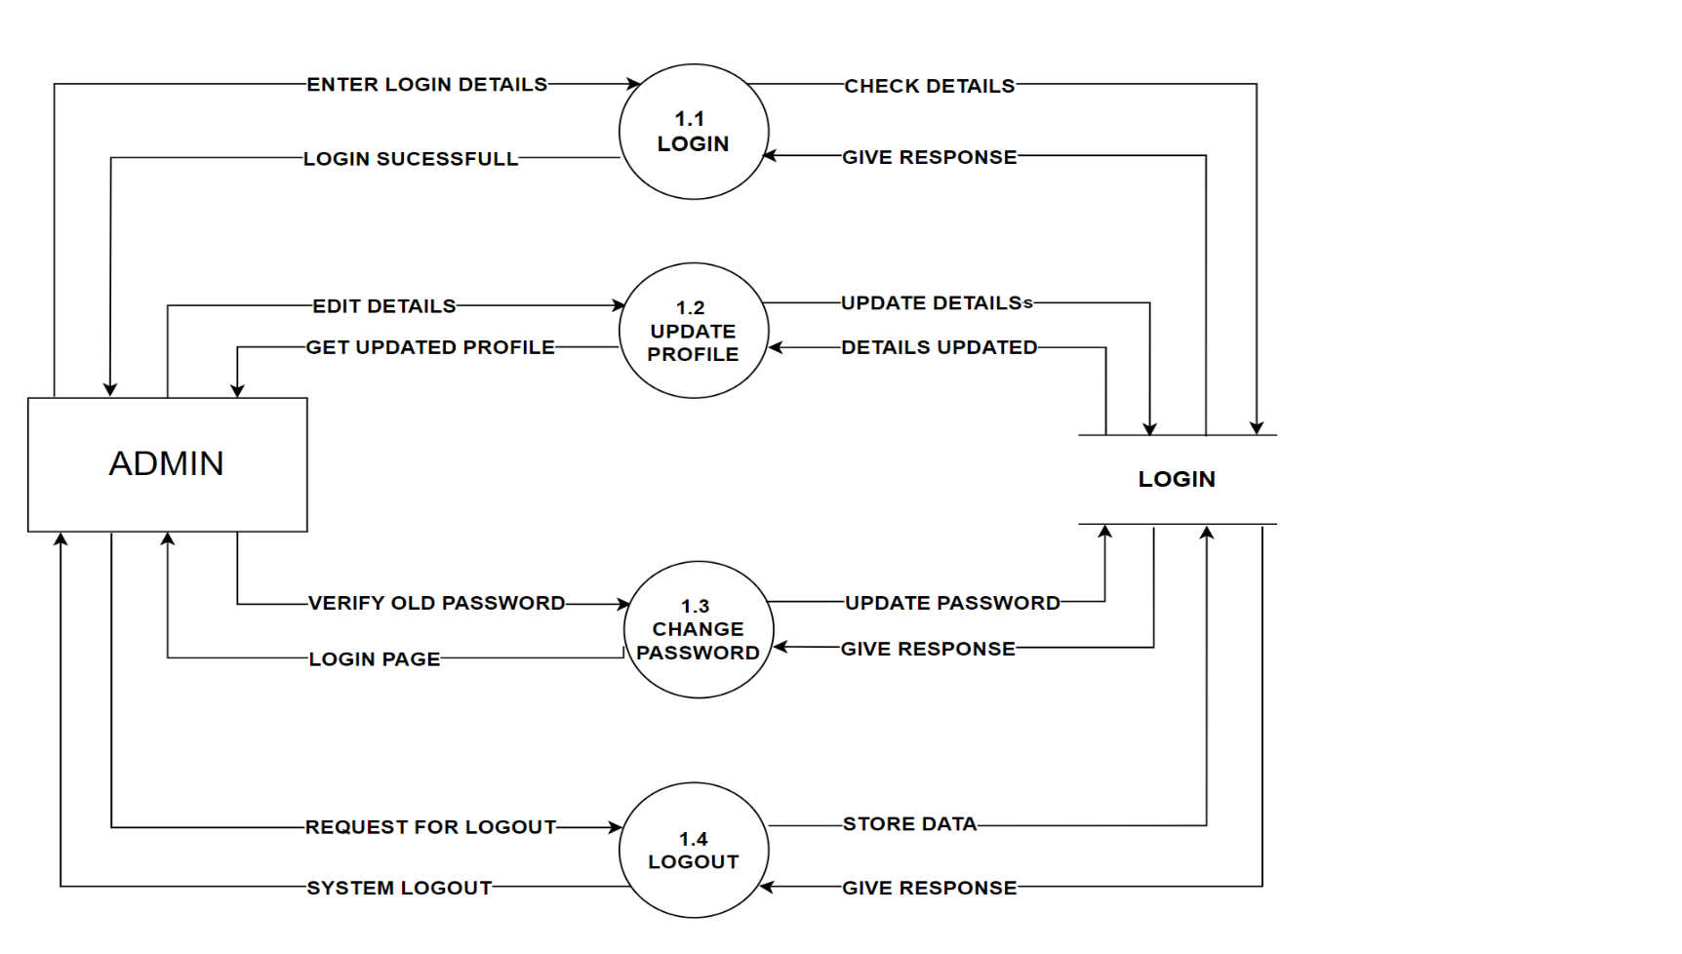

**[Figure 4.6 :** Data Flow Diagram Of Admin [Login]]

**4.3.2 Level 2 Data Flow Diagram Of Admin [Services]:**

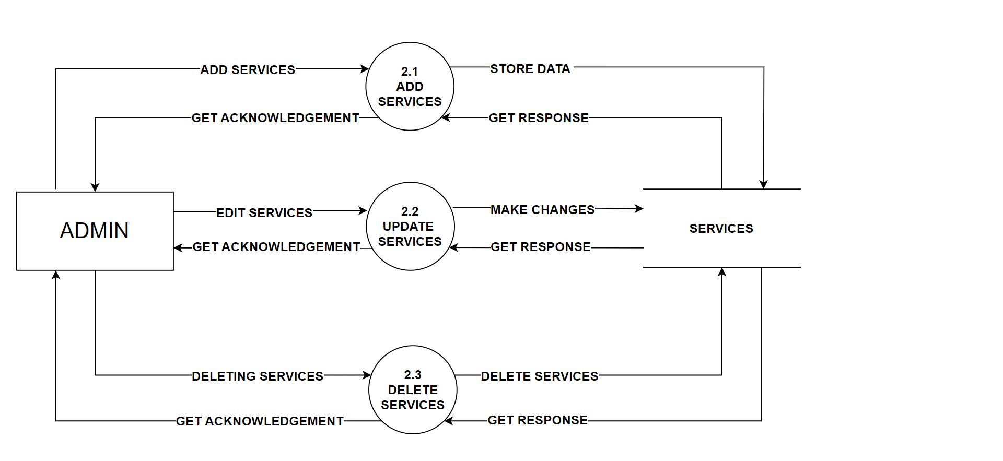

**[Figure 4.7 :** Data Flow Diagram Of Admin [Services]]

**4.3.3 Level 2 Data Flow Diagram Of Admin [Vets]:**

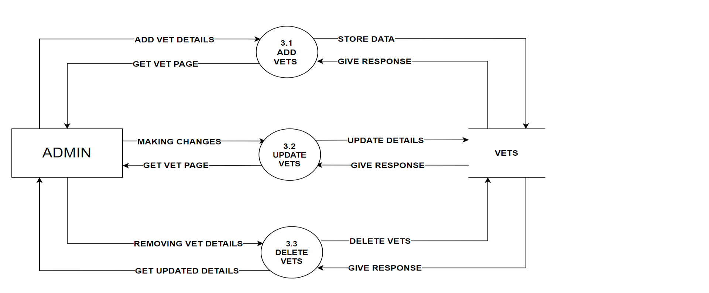

**[Figure 4.8 :** Data Flow Diagram Of Admin [Vets]]

### 

### DFD LEVEL 2

### USER DIAGRAMS

**4.3.4 Level 2 Data Flow Diagram Of User [Login]:**

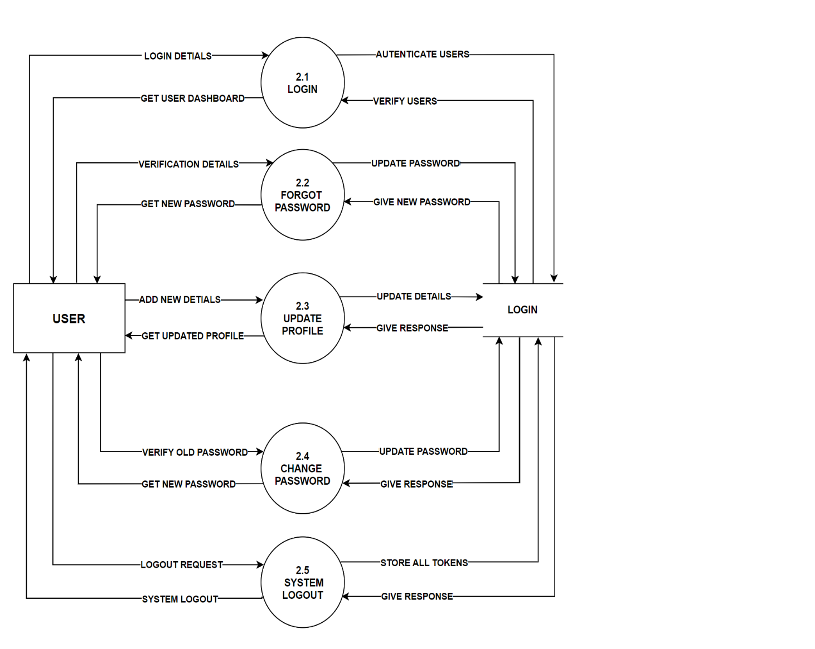

**[Figure 4.9 :** Data Flow Diagram Of User [Login]]

**4.3.5 Level 2 Data Flow Diagram Of User [Services]:**

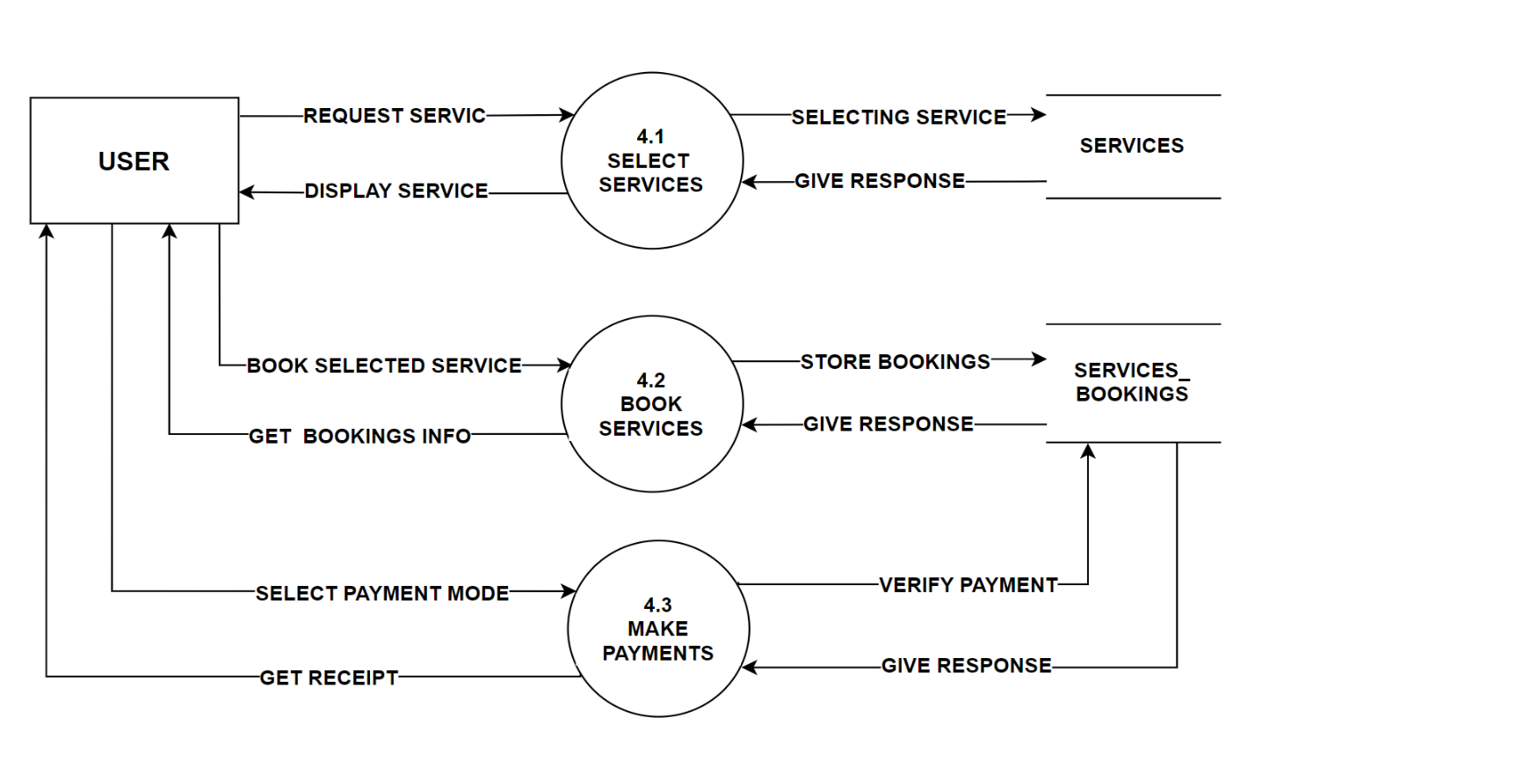

**[Figure 4.10 :** Data Flow Diagram Of User [Services]]

**4.3.6 Level 2 Data Flow Diagram Of User [Adoption]:**

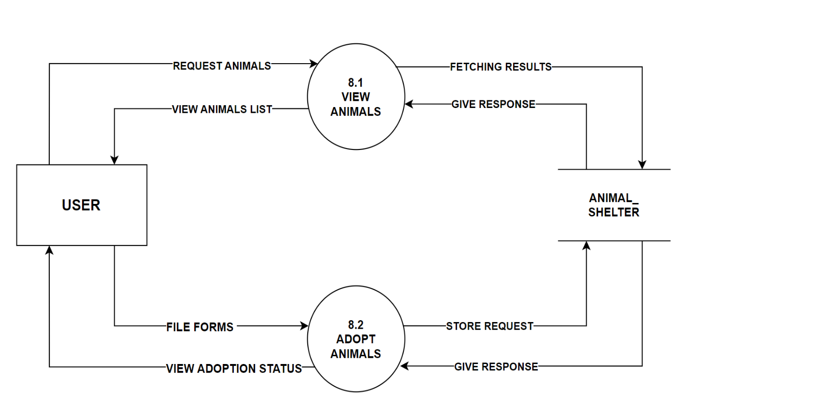

**[Figure 4.11 :** Data Flow Diagram Of User [Adoption]]

# CHAPTER: 5

# ENTITY RELATIONSHIP

**DIAGRAM**

* **ER Diagram :**
* Stands for Entity Relationship Diagram, also known as ERD is a diagram that displays the relationship of entity sets stored in a database. In other words, ER diagrams help to explain the logical structure of databases. ER diagrams are created based on three basic concepts: entities, attributes and relationships.

### Three Types of Cardinality Relationship mainly used in ER Diagram are:

### One to one:

### For one Occurrence of the first entity there can exist only one related occurrence of the second entity and vice – versa.

### One to Many:

### For one Occurrence of the entity there can exist many related Occurrence of the second entity, it doesn’t matter which is first or second.

### Many to Many:

### For one Occurrence of the first entity, there can exist many related occurrences of the second entity, and for occurrence of the second entity there can exist many occurrences of the first entity

### ER Diagrams uses different symbols such as:

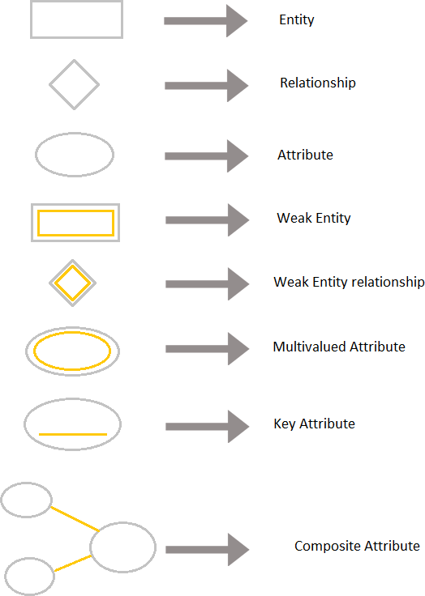

**[Figure 5.1:** ER Diagram Symbols]

### E.R DIAGRAM:

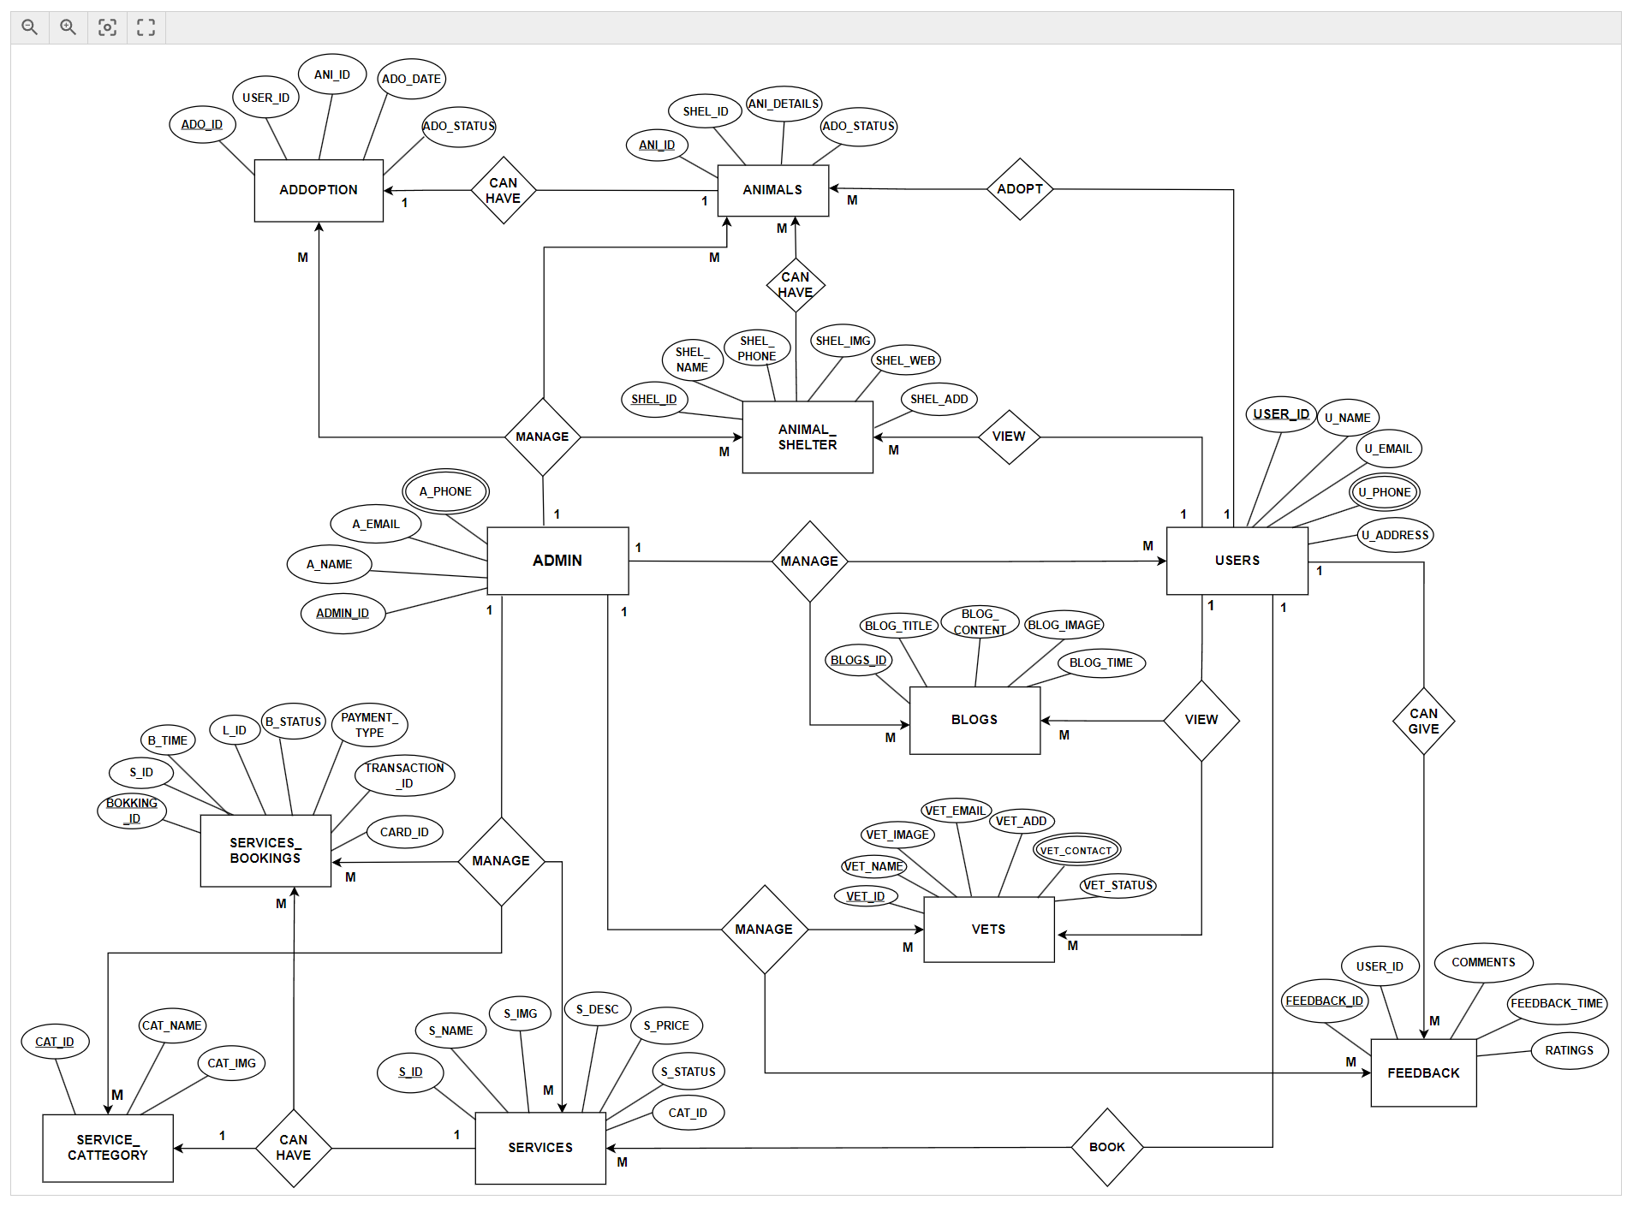

**[Figure 5.2** ER diagram**]**

# CHAPTER: 6

# DATA DICTIONARY

* **Data Dictionary:**
* A data dictionary is a collection of descriptions of data objects or items in a data progress model for the benefit of programmers and others who need to refer to them.
* A first step in analyzing a system of objects with which users Interact is to identify each object and its relationship to other objects.
* This progress is called data modeling and results in a picture of object relationship.
* After each data object or item is given a descriptive name, its relationship is described, the type of data is described, possible predefined values are listed, and a brief textual description is provided. This collection can be organized for reference into a book called a data dictionary.
* When developing programs that use the data model, a data dictionary can be consulted to understand where a data item fits in the structure, what values it may contain, and basically what the data item means in real-world terms.
* For example, a bank or group of banks could model the data objects involved in consumer banking. They could then provide a data dictionary for a bank’s programmers. The data dictionary would describe each of the data items in its data model for consumer banking (for example, “ Account holder” and “ Available credit ”).

### DATA DICTIONARY

**1. ROLE_TABLE:-**

Table Name : Role

Description : Table is used to store the information about the role.

Primary Key : ROLE_ID

|  |  |  |  |  |
| --- | --- | --- | --- | --- |
| SR  **NO.** | **ATTRIBUTE** | **CONSTRAINT** | **DATA TYPE** | **DESCRIPTION** |
| **1** | ROLE_ID | PRIMARY_KEY | INT  (10) | PRIMARY KEY OF TABLE |
| **2** | ROLE_TYPE | NOT_NULL | VARCHAR (20) | 0- ADMIN 1-USER |

**[Table 6.1.1:** Role Table**]**

**2. LOGIN TABLE :**

Table Name : Login

Description : This table is used to store the information about the login.

Primary Key : USER_ID

Foreign Key : ROLE

|  |  |  |  |  |
| --- | --- | --- | --- | --- |
| **SR NO.** | **ATTRIBUTE** | **CONSTRAINT** | **DATA TYPE** | **DESCRIPTION** |
| **1** | USER_ID | PRIMARY_KEY | INT (10) | PRIMARY KEY OF TABLE |
| **2** | ROLE | FOREIGN KEY | INT (10) | MAPPED WITH ROLE TABLE |
| **3** | FIRST_NAME | NOT_NULL | VARCHAR (20) | DISPLAY THE FIRST  NAME |
| **4** | LAST_NAME | NOT_NULL | VARCHAR (20) | DISPLAY THE LAST NAME |
| **5** | PHONE_NO. | NOT_NULL | VARCHAR(10) | DISPLAY THE PHONE NUMBER |
| **6** | EMAIL_ID | NOT_NULL | VARCHAR (20) | DISPLAY EMAIL ADDRESS |
| **7** | PASSWORD | NOT_NULL | VARCHAR (30) | DISPLAY PASSWORD |
| **8** | ADDED_ON | NOT_NULL | DATE TIME | DISPLAY DATE AND TIME OF LOGIN |
| **9** | STATUS | NOT_NULL | INT (20) | 0-INACTIVE    1-ACTIVE |

**[Table 6.1.2:** Login Table**]**

**3. ADDRESS TABLE:-**

Table Name : Address

Description : This table is used to store the address of user.

Primary Key : ADD_ID

Foreign Key : USER_ID

|  |  |  |  |  |
| --- | --- | --- | --- | --- |
| **SR NO.** | **ATTRIBUTE** | **CONSTRAINT** | **DATA TYPE** | **DESCRIPTION** |
| **1** | ADD_ID | PRIMARY_KEY | INT (10) | PRIMARY KEY OF TABLE |
| **2** | USER_ID | FOREIGN KEY | INT (10) | MAPPED WITH USER TABLE |
| **3** | ADD_TYPE | NOT_NULL | VARCHAR (20) | 0- HOME 1-WORK 2-OTHER |
| **4** | CITY | NOT_NULL | VARCHAR (20) | DISPLAY CITY NAME |
| **5** | STREET_  ADDRESS | NOT_NULL | TEXTAREA (50) | DISPLAY DESCRIPTION OF THE ADDRESS |

**[Table 6.1.3:** Address Table**]**

**4. SERVICE CATEGORY TABLE:-**

Table Name : Service Category

Description : This table is used to store the category of services.

Primary Key : CAT_ID

|  |  |  |  |  |
| --- | --- | --- | --- | --- |
| **SR NO.** | **ATTRIBUTE** | **CONSTRAINT** | **DATA TYPE** | **DESCRIPTION** |
| **1** | CAT_ID | PRIMARY_KEY | INT (10) | PRIMARY KEY FOR THIS TABLE |
| **2** | CAT_NAME | NOT_NULL | VARCHAR (30) | DISPLAY THE CATEGORY NAME |
| **3** | CAT_IMAGE | NOT_NULL | VARCHAR(100) | DISPLAY THE CATEGORY IMAGE |

**[Table 6.1.4:** Category Table**]**

**5. SERVICE_TABLE:-**

Table Name : Service

Description : This table is used to store the services.

Primary Key : S_ID

Foreign Key : CAT_ID

|  |  |  |  |  |
| --- | --- | --- | --- | --- |
| **SR NO.** | **ATTRIBUTE** | **CONSTRAINT** | **DATA TYPE** | **DESCRIPTION** |
| **1** | S_ID | PRIMARY_KEY | INT (10) | PRIMARY KEY FOR THIS TABLE |
| **2** | CAT_ID | FOREIGN_KEY | INT (10) | MAPPED WITH CATEGORY TABLE |
| **3** | S_NAME | NOT_NULL | VARCHAR (30) | DISPLAY THE SERVICE NAME |
| **4** | S_IMAGE | NOT_NULL | VARCHAR (100) | DISPLAY THE IMAGE OF SERVICE |
| **5** | S_DES | NOT_NULL | VARCHAR (100) | DISPLAY THE DESCRIPTION OF SERVICE |
| **6** | S_PRICE | NOT_NULL | FLOAT (10) | DISPLAY THE PRICE OF SERVICE |
| **7** | S_STATUS | NOT_NULL | VARCHAR (20) | 0-INACTIVE    1-ACTIVE |

**[Table 6.1.5:** Service Table**]**

**6. CARD TABLE :-**

Table Name : Card

Description : This table will store card details of the user for payments.

Primary Key : CARD_ID

Foreign Key : USER_ID

|  |  |  |  |  |
| --- | --- | --- | --- | --- |
| **SR NO.** | **ATTRIBUTE** | **CONSTRAINT** | **DATA TYPE** | **DESCRIPTION** |
| **1** | CARD_ID | PRIMARY_KEY | INT (10) | MAPPED WITH THE ANIMAL SHELTER TABLE |
| **2** | USER_ID | FOREIGN KEY | INT (10) | MAPPED WITH USER TABLE |
| **3** | NAME_ON_CARD | NOT_NULL | VARCHAR (20) | DISPLAY THE NAME ON CARD |
| **4** | CARD_NO. | NOT_NULL | VARCHAR (20) | DISPLAY THE CARD NUMBER |
| **5** | CVV | NOT_NULL | INT (3) | DISPLAY THE CVV OF THE CARD |
| **6** | EXPIRY_DATE | NOT_NULL | VARCHAR (10) | DISPLAY THE EXPIRY DATE |

**[Table 6.1.6:** Card Table**]**

**7. SERVICE BOOKING TABLE:-**

Table Name : Service Booking

Description : This table is used to process the booking.

Primary Key : SB_ID

Foreign Key : S_ID, USER_ID, CARD_ID

|  |  |  |  |  |
| --- | --- | --- | --- | --- |
| **SR NO.** | **ATTRIBUTE** | **CONSTRAINT** | **DATA TYPE** | **DESCRIPTION** |
| **1** | SB_ID | PRIMARY_KEY | INT (10) | PRIMARY KEY FOR THIS TABLE |
| **2** | S_ID | FOREIGN_KEY | INT (10) | MAPPED WITH SERVICE TABLE |
| **3** | USER_ID | FOREIGN_KEY | INT (10) | MAPPED WITH LOGIN TABLE |
| **4** | CARD_ID | FOREIGN_KEY | INT (10) | MAPPED WITH CARD TABLE |
| **5** | SB_TIME | NOT_NULL | DATE TIME | DISPLAY THE DATE AND TIME OF SERVICE BOOKINGS |
| **6** | SB_STATUS | NOT_NULL | VARCHAR (20) | 0-PENDING  1-CONFIRMED  2-COMPLETED |
| **7** | AMMOUNT_PAID | NOT_NULL | FLOAT (10) | PRICE OF SERVICES |
| **8** | PAYMENT_TYPE | NOT_NULL | VARCHAR (20) | 0-ONLINE  1-OFFLINE |
| **9** | TRANSACTION_  STATUS | NOT_NULL | VARCHAR (20) | 0-SUCCESSFUL  1-UNSUCCESSFUL |

**[Table 6.1.7:** Service Booking Table**]**

**8. VET TABLE:-**

Table Name : Vet

Description : This table is used to store details of vet

Primary Key : VET_ID

|  |  |  |  |  |
| --- | --- | --- | --- | --- |
| **SR NO.** | **ATTRIBUTE** | **CONSTRAINT** | **DATA TYPE** | **DESCRIPTION** |
| **1** | VET_ID | PRIMARY_KEY | INT (10) | PRIMARY KEY FOR THIS TABLE |
| **2** | VET_NAME | NOT_NULL | VARCHAR (30) | DISPLAY THE VET NAME |
| **3** | VET_IMAGE | NOT_NULL | VARCHAR (100) | IMAGE OF THE VET |
| **4** | VET_EMAIL | NOT_NULL | VARCHAR (20) | EMAIL OF THE VET |
| **5** | VET_CONTACT. | NOT_NULL | VARCHAR (10) | PHONE NO. OF THE VET |
| **6** | VET_STATUS | NOT_NULL | VARCHAR (20) | 0-INACTIVE  1-ACTIVE |
| **7** | VET_ADDRESS | NOT_NULL | VARCHAR (100) | ADDRESS OF THE VET CLINIC |

**[Table 6.1.8:** Vet Table**]**

**9. PET SHOP TABLE:-**

Table Name : Pet Shop

Description : This table is used to store details of the pet shops.

Primary Key : SHOP_ID

|  |  |  |  |  |
| --- | --- | --- | --- | --- |
| **SR NO.** | **ATTRIBUTE** | **CONSTRAINT** | **DATA TYPE** | **DESCRIPTION** |
| **1** | SHOP_ID | PRIMARY_KEY | INT (10) | PRIMARY KEY FOR THIS TABLE |
| **2** | SHOP_DESC | NOT_NULL | VARCHAR (100) | DISPLAY THE DESCRIPTION OF SHOP |
| **3** | SHOP_CONTACT | NOT_NULL | VARCHAR (10) | CONTACT DETAIL OF SHOP |
| **4** | SHOP_ADDRESS | NOT_NULL | VARCHAR (100) | DISPLAY THE ADDRESS OF SHOP |
| **5** | SHOP_EMAIL | NOT_NULL | VARCHAR (30) | DISPLAY THE MAIL ID OF THE SHOP |
| **6** | SHOP_IMG | NOT_NULL | VARCHAR (100) | DISPLAY THE IMAGE OF THE SHOP |
| **7** | SHOP_TIMINGS | NOT_NULL | DATE TIME | DISPLAY THE TIMINGS OF SHOP |

**[Table 6.1.9:** Pet Shop Table**]**

**10. BLOG TABLE:-**

Table Name : Blog

Description : This table is used to store blogs.

Primary Key : BLOG_ID

|  |  |  |  |  |
| --- | --- | --- | --- | --- |
| **SR NO.** | **ATTRIBUTE** | **CONSTRAINT** | **DATA TYPE** | **DESCRIPTION** |
| **1** | BLOG_ID | PRIMARY_KEY | INT (10) | PRIMARY KEY FOR THIS TABLE |
| **2** | BLOG_TITLE | NOT_NULL | VARCHAR (50) | TITLE OF THE BLOG |
| **3** | BLOG_CONTENT | NOT_NULL | TEXTAREA | MAIN CONTENT OF THE BLOG |
| **4** | BLOG_PUB_DATE | NOT_NULL | DATE TIME | DESCRIPTION OF THE BLOG |
| **5** | BLOG_IMG | NOT_NULL | VARCHAR(100) | DISPLAY IMAGES RELATED TO BLOG |
| **6** | BLOG_TIME | NOT_NULL | DATE TIME | DISPLAY THE TIMINGS OF BLOG |

**[Table 6.1.10:** Blog Table**]**

**11. ANIMAL SHELTER TABLE:-**

Table Name : Animal Shelter

Description : This table is used to store details about animal shelters.

Primary Key : SHEL_ID

|  |  |  |  |  |
| --- | --- | --- | --- | --- |
| **SR NO.** | **ATTRIBUTE** | **CONSTRAINT** | **DATA TYPE** | **DESCRIPTION** |
| **1** | SHEL_ID | PRIMARY_KEY | INT (10) | PRIMARY KEY FOR THIS TABLE |
| **2** | SHEL_NAME | NOT_NULL | VARCHAR (30) | DISPLAY THE SHELTER NAME |
| **3** | SHEL_EMAIL | NOT_NULL | VARCHAR (20) | EMAIL OF THE ANIMAL SHELTER |
| **4** | SHEL_PHONE. | NOT_NULL | VARCHAR (10) | PHONE NO. OF THE SHELTER |
| **5** | SHELTER_IMG | NOT_NULL | VARCHAR (100) | IMAGE OF THE SHELTER |
| **6** | SHELTER_WEBSITE | NULL | VARCHAR (50) | WEBSITE OF ANIMAL SHELTER |
| **7** | SHEL_ADDRESS | NOT_NULL | VARCHAR (100) | ADDRESS OF THE SHELTER |
| **8** | SHEL_STATUS | NOT_NULL | VARCHAR (20) | 0-INACTIVE  1-ACTIVE |

**[Table 6.1.11:** Animal Shelter Table**]**

**12. ANIMAL TABLE:-**

Table Name : Animal

Description : This table is used to store the details of animals

Primary Key : ANI_ID

Foreign Key : SHEL_ID

|  |  |  |  |  |
| --- | --- | --- | --- | --- |
| **SR NO.** | **ATTRIBUTE** | **CONSTRAINT** | **DATA TYPE** | **DESCRIPTION** |
| **1** | ANI_ID | PRIMARY_KEY | INT (10) | PRIMARY KEY FOR THIS TABLE |
| **2** | SHEL_ID | FOREIGN_KEY | INT (20) | MAPED WITH ANIMAL SHELTER TABLE |
| **3** | ANI_NAME | NOT_NULL | VARCHAR (30) | DISPLAY THE ANIMAL NAME |
| **4** | ANI_IMAGE | NOT_NULL | VARCHAR (100) | IMAGE OF THE ANIMAL |
| **5** | ANI_SPECIES | NOT_NULL | VARCHAR (20) | DISPLAY THE SPECIES OF ANIMAL |
| **6** | ANI_BREED | NOT_NULL | VARCHAR (20) | DISPLAY THE BREED OF ANIMAL |
| **7** | ANI_HEALTH | NOT_NULL | VARCHAR (20) | DISPLAY THE HEALTH OF ANIMAL |
| **8** | ANI_AGE | NOT_NULL | INTEGER (20) | DISPLAY THE AGE OF ANIMAL |
| **9** | ANI_SEX | NOT_NULL | VARCHAR (20) | DISPLAY THE GENDER OF ANIMAL |
| **10** | ADO_STATUS | NOT_NULL | VARCHAR (20) | 0-ADOPTED  1-NOT ADOPTED |

**[Table 6.1.12:** Animal Table**]**

**13. ADOPTION TABLE:-**

Table Name : Adoption

Description : This table is used to store the details of adoption process.

Primary Key : ADO_ID

Foreign Key : ANI_ID, USER-ID

|  |  |  |  |  |
| --- | --- | --- | --- | --- |
| **SR NO.** | **ATTRIBUTE** | **CONSTRAINT** | **DATA TYPE** | **DESCRIPTION** |
| **1** | ADO_ID | PRIMARY_KEY | INT (10) | PRIMARY KEY FOR THIS TABLE |
| **2** | ANI_ID | FOREIGN_KEY | INT (10) | MAPPED WITH ANIMAL TABLE |
| **3** | USER_ID | FOREIGN_KEY | INT (10) | MAPPED WITH LOGIN TABLE |
| **4** | ADO_DATE | NOT_NULL | DATE TIME | DISPLAY THE DATE AND TIME OF ADOPTION REQUEST BY USER |
| **5** | ADO_STATUS | NOT_NULL | VARCHAR (20) | 0-PENDING  1-ACCEPTED  2-REJECTED |

**[Table 6.1.13:** Adoption Table**]**

**14. RESCUE CENTER TABLE:-**

Table Name : Rescue Center

Description : This table is used to store the details of rescue centers.

Primary Key : RC_ID

|  |  |  |  |  |
| --- | --- | --- | --- | --- |
| **SR NO.** | **ATTRIBUTE** | **CONSTRAINT** | **DATA TYPE** | **DESCRIPTION** |
| **1** | RC_ID | PRIMARY_KEY | INT (10) | PRIMARY KEY FOR THIS TABLE |
| **2** | RC_NAME | NOT_NULL | VARCHAR (30) | DISPLAY THE CENTER NAME |
| **3** | RC_EMAIL | NOT_NULL | VARCHAR (20) | EMAIL OF THE CENTER |
| **4** | RC_CONTACT. | NOT_NULL | VARCHAR (10) | PHONE NO. OF THE CENTER |
| **5** | RC_IMG | NOT_NULL | VARCHAR (100) | IMAGE OF THE CENTER |
| **6** | RC_WEBSITE | NULL | VARCHAR (50) | DISPLAY  WEBSITE OF CENTER |
| **7** | RC_ADDRESS | NOT_NULL | VARCHAR (50) | ADDRESS OF THE CENTER |
| **8** | RC_STATUS | NOT_NULL | VARCHAR (20) | 0-INACTIVE  1-ACTIVE |

# [Table 6.1.14: Rescue Centers Table]

**15. CONTACT US TABLE:-**

Table Name : Contact Us

Description : This table is used for storing the contact details.

Primary Key : INQUIRY_ID

|  |  |  |  |  |
| --- | --- | --- | --- | --- |
| **SR NO.** | **ATTRIBUTE** | **CONSTRAINT** | **DATA TYPE** | **DESCRIPTION** |
| **1** | INQUIRY_ID | PRIMARY_KEY | INT (10) | PRIMARY KEY FOR THIS TABLE |
| **2** | PERSON_NAME | NOT_NULL | VARCHAR (30) | NAME OF PERSON |
| **3** | EMAIL_ID | NOT_NULL | VARCHAR (30) | EMAIL OF PERSON |
| **4** | PHONE_NO | NOT_NULL | VARCHAR (10) | PHONE NO OF PERSON |
| **5** | SUBJECT | NOT_NULL | VARCHAR (255) | MESSAGE FROM PERSON |
| **6** | INQUIRY_TIME | NOT_NULL | DATE TIME | TIME OF CONTACT |

# [Table 6.1.15: Contact Us Table]

**16. FEEDBACK TABLE:-**

Table Name : Feedback

Description : This table is used to store the feedback's ratings and comments.

Primary Key : FEEDBACK_ID

|  |  |  |  |  |
| --- | --- | --- | --- | --- |
| **SR NO.** | **ATTRIBUTE** | **CONSTRAINT** | **DATA TYPE** | **DESCRIPTION** |
| **1** | FEEDBACK_ID | PRIMARY_KEY | INT (10) | PRIMARY KEY FOR THIS TABLE |
| **2** | USER_ID | FOREIGN_KEY | INT (10) | MAPPED WITH LOGIN TABLE |
| **3** | RATINGS | NOT_NULL | INT (5) | DISPLAY RATINGS |
| **4** | COMMENTS | NOT_NULL | VARCHAR (20) | DISPLAY COMMENTS |
| **5** | FEEDBACK_TIME | NOT_NULL | DATE TIME | DISPLAY THE DATE TIME OF FEEDBACK |

# [Table 7.1.16: Feedback Table]

# CHAPTER: 7

# Conclusion

* **Conclusion:**
* PetxHub is a web application designed to facilitate Animal Health & Care Services. Through this platform, users can conveniently book various animal services, connect with nearby veterinarians, pet shops, and animal shelters, all from the comfort of their location, at any time. Our platform extends its reach to promote animal welfare by allowing users to adopt animals from shelters and contribute to NGO through donations. Furthermore, users can access a wealth of knowledge on animal care through our informative blogs.

# CHAPTER: 8

**Bibliography**

* **References:**
* <https://www.w3schools.com/>
* <https://www.google.com/>
* <https://app.diagrams.net/>

# THANK YOU